ASSESSMENT TOOL 1-Constraint Based Problem Solving

ITA0401-Statistics with R Programming
S. Sharon Surya
192324246

Question 1. Student Marks Analysis (Vectors)
Pseudocode
Start
Store marks of 10 students in a vector.
Assign the first mark as highest and lowest.
Initialize sum as 0.
For each mark in the vector:
If mark is greater than highest, update highest.
If mark is less than lowest, update lowest.
Add mark to sum.
Calculate average = sum / number of students.
Display highest mark.
Display lowest mark.
Display average mark.
Stop

CODE:
marks <- c(78,85,92,67,88,74,95,81,69,90)

highest <- marks[1]
lowest <- marks[1]
sum_marks <- 0

for(i in 1:length(marks))
{
if(marks[i] > highest)
{
highest <- marks[i]
}

if(marks[i] < lowest)
{
lowest <- marks[i]
}

sum_marks <- sum_marks + marks[i]
}

average <- sum_marks/length(marks)

highest
lowest
average
OUTPUT:
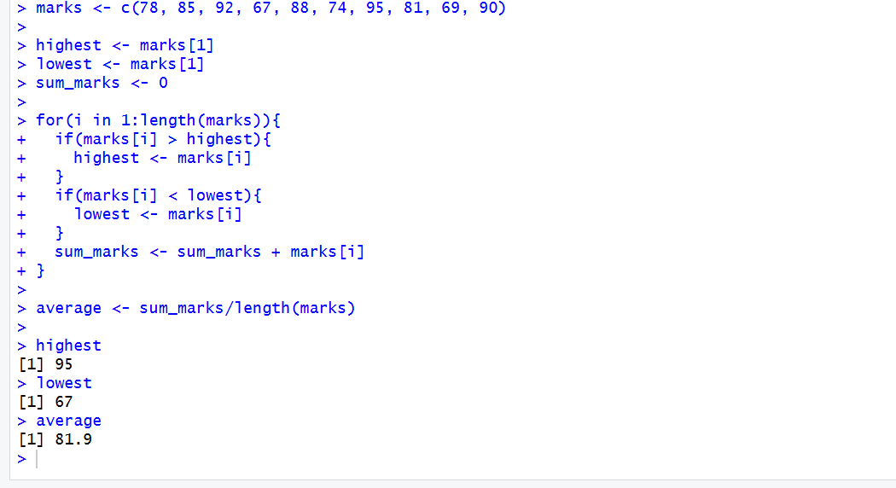
Constraints:
- Do not use built-in functions like sort().
- Use only vector indexing and arithmetic operators.
- Display the highest, lowest, and average marks.

Question 2. Employee Salary Matrix

Pseudocode
Start
Create a 4 × 3 salary matrix.
Calculate department-wise total salary.
Find the department having maximum salary.
Display total salary.
Display department number.
Stop

CODE:

salary <- matrix(c(
30000,5000,4000,
32000,5500,4200,
28000,4500,3800,
35000,6000,4500
),nrow=4,byrow=TRUE)

total <- salary[,1] + salary[,2] + salary[,3]

total

which.max(total)

OUPUT:

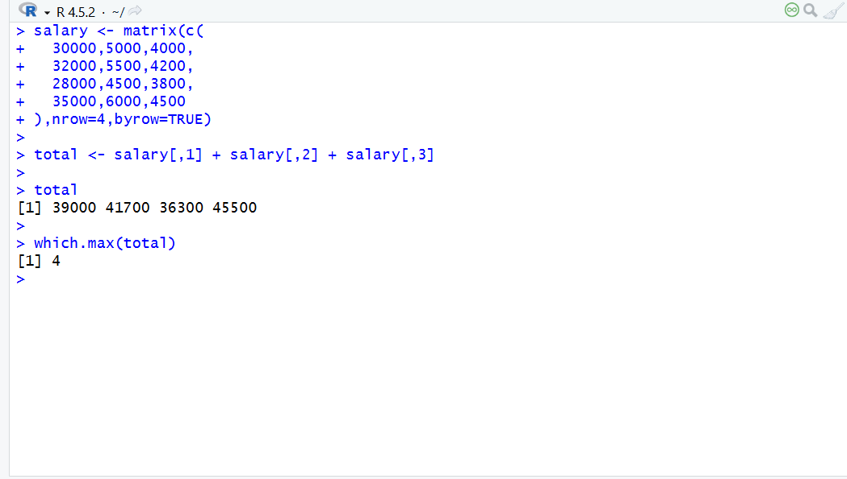
Constraints:
- Do not create separate vectors.
- Calculate total salary department-wise using matrix operations only.
- Display the department with the maximum total salary.

Question 3. Rainfall Data (Arrays)
Pseudocode:
Start
Create a three-dimensional rainfall array.
Initialize annual rainfall for each city.
For every city:
For every season:
For every year:
Add rainfall.
Find the city with highest rainfall.
Display annual rainfall.
Display city number.
Stop

CODE:
rainfall <- array(c(
120,150,130,140,
110,160,125,135,

100,140,120,150,
105,145,115,155,

130,170,140,160,
125,165,135,155
),dim=c(3,4,2))

annual <- c(0,0,0)

for(i in 1:3)
{
total <- 0

for(j in 1:4)
{
for(k in 1:2)
{
total <- total + rainfall[i,j,k]
}
}

annual[i] <- total
}

annual

which.max(annual)

rainfall <- array(c(
120,150,130,140,
110,160,125,135,

100,140,120,150,
105,145,115,155,

130,170,140,160,
125,165,135,155
),dim=c(3,4,2))

annual <- c(0,0,0)

for(i in 1:3)
{
total <- 0

for(j in 1:4)
{
for(k in 1:2)
{
total <- total + rainfall[i,j,k]
}
}

annual[i] <- total
}

annual

which.max(annual)

OUTPUT:
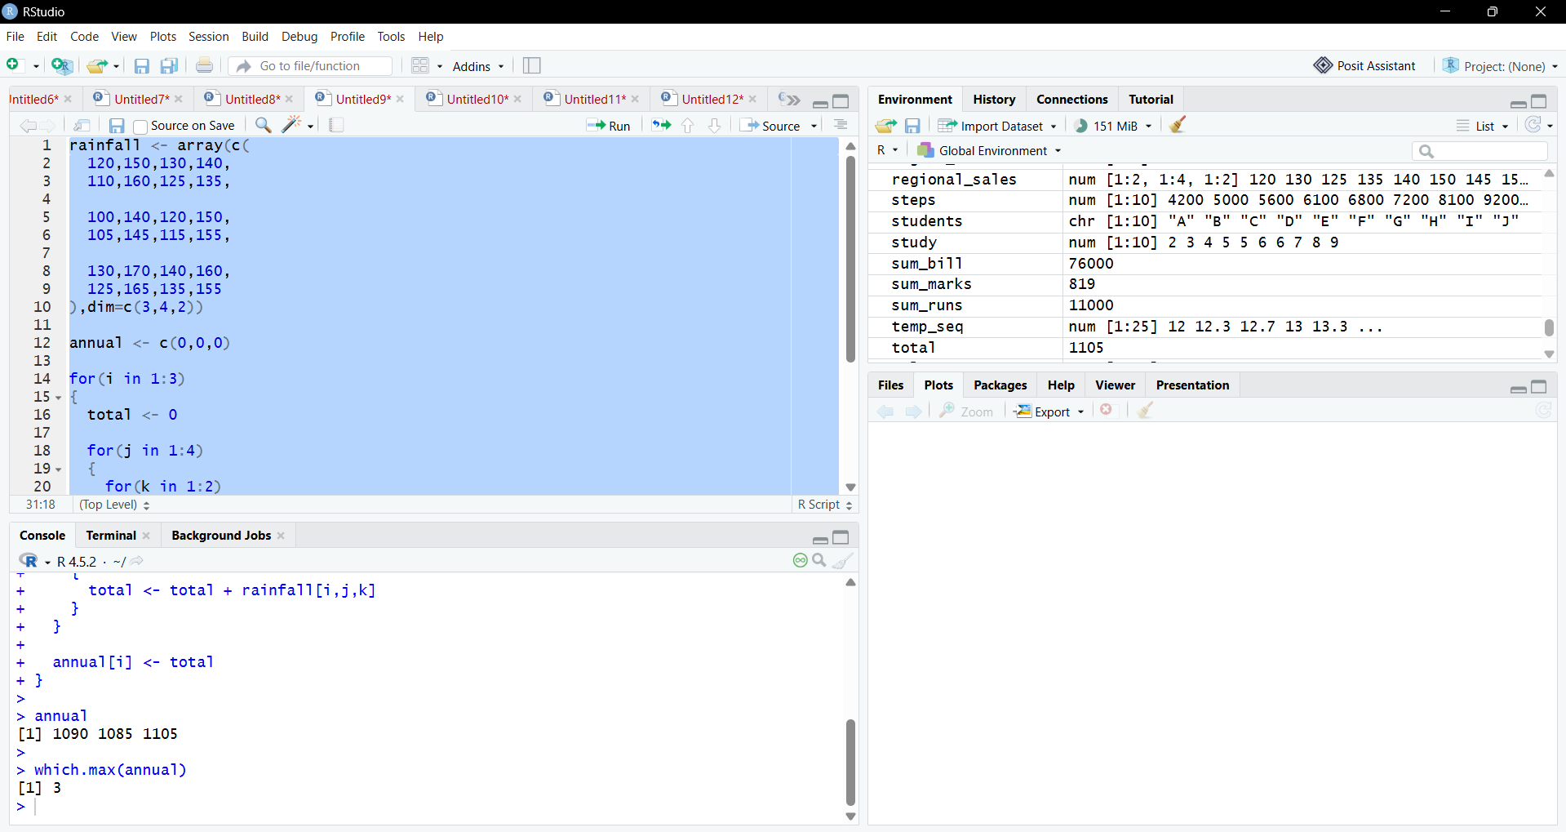
Constraints:
- Use only array indexing.
- Find the city with the highest annual rainfall.
- Do not convert the array into a matrix or data frame.

Question 4. Hospital Patient Records (Lists)
Pseudocode:
Start
Create a list containing patient details.
Identify patients whose age is above 60.
Display their ID, Name and Age.
Calculate total hospital bill.
Calculate average bill.
Display average bill.
Stop

CODE:
patients <- list(
ID=c(101,102,103,104,105),
Name=c("Arun","Bala","Cathy","David","Eva"),
Age=c(45,68,72,39,65),
BloodGroup=c("A+","B+","O+","AB+","A-"),
Bill=c(12000,18000,22000,9000,15000)
)

index <- patients$Age > 60

patients$ID[index]

patients$Name[index]

patients$Age[index]

sum_bill <- 0

for(i in 1:length(patients$Bill))
{
sum_bill <- sum_bill + patients$Bill[i]
}

average_bill <- sum_bill/length(patients$Bill)

average_bill

OUTPUT:

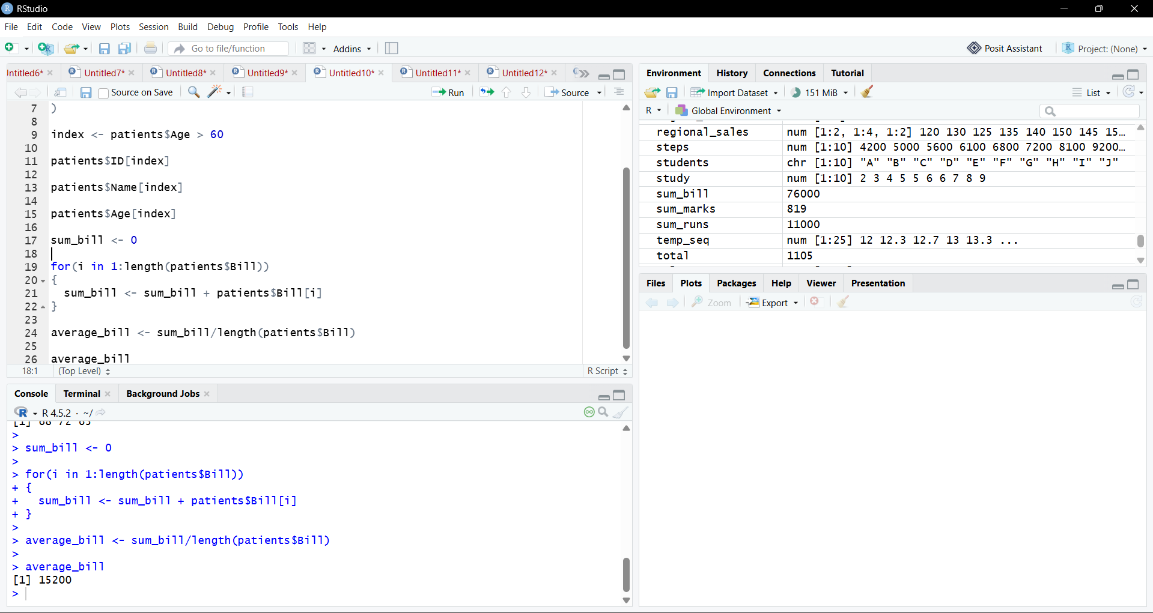
Constraints:
- Store different data types in a single list.
- Retrieve only patients aged above 60.
- Calculate the average hospital bill without converting the list into another data structure.

Question 5. Product Inventory (Factors)
Pseudocode
Start
Create factor containing product categories.
Display categories in alphabetical order.
Initialize category counters.
Traverse each product.
Increase corresponding category count.
Display category count.
Stop

CODE:
products <- factor(c(
"Electronics",
"Grocery",
"Stationery",
"Electronics",
"Grocery",
"Grocery",
"Stationery",
"Electronics",
"Stationery",
"Grocery"
))

levels(products)

count <- c(0,0,0)

for(i in 1:length(products))
{
if(products[i] == "Electronics")
{
count[1] <- count[1] + 1
}
else if(products[i] == "Grocery")
{
count[2] <- count[2] + 1
}
else
{
count[3] <- count[3] + 1
}
}

Count

OUTPUT:
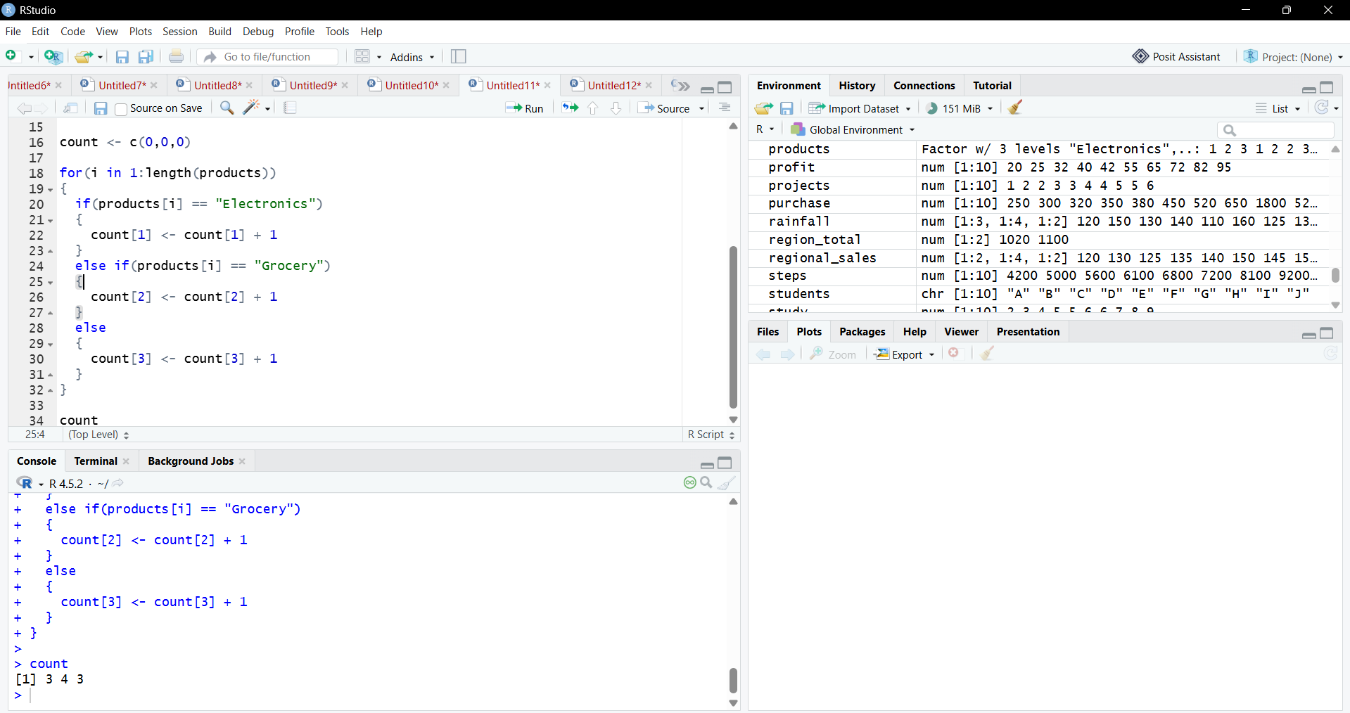
Constraints:
- Count the number of products in each category.
- Do not use table().
- Display categories in alphabetical order.

Question 6. Cricket Performance Analysis (Data Frames)
Pseudocode
Start
Create a data frame containing player details.
Select players with Strike Rate greater than 120.
Calculate total runs scored.
Compute average runs.
Display players with Strike Rate greater than 120.
Display average runs.
Stop

CODE:
players <- data.frame(
Name=c("Rohit","Virat","Gill","Hardik","Surya"),
Matches=c(50,60,40,35,45),
Runs=c(2500,3200,1800,1400,2100),
Wickets=c(2,5,0,45,1),
StrikeRate=c(125,118,130,128,145)
)

players[players$StrikeRate>120,]

sum_runs <- 0

for(i in 1:nrow(players))
{
sum_runs <- sum_runs + players$Runs[i]
}

average_runs <- sum_runs/nrow(players)

average_runs

OUTPUT:

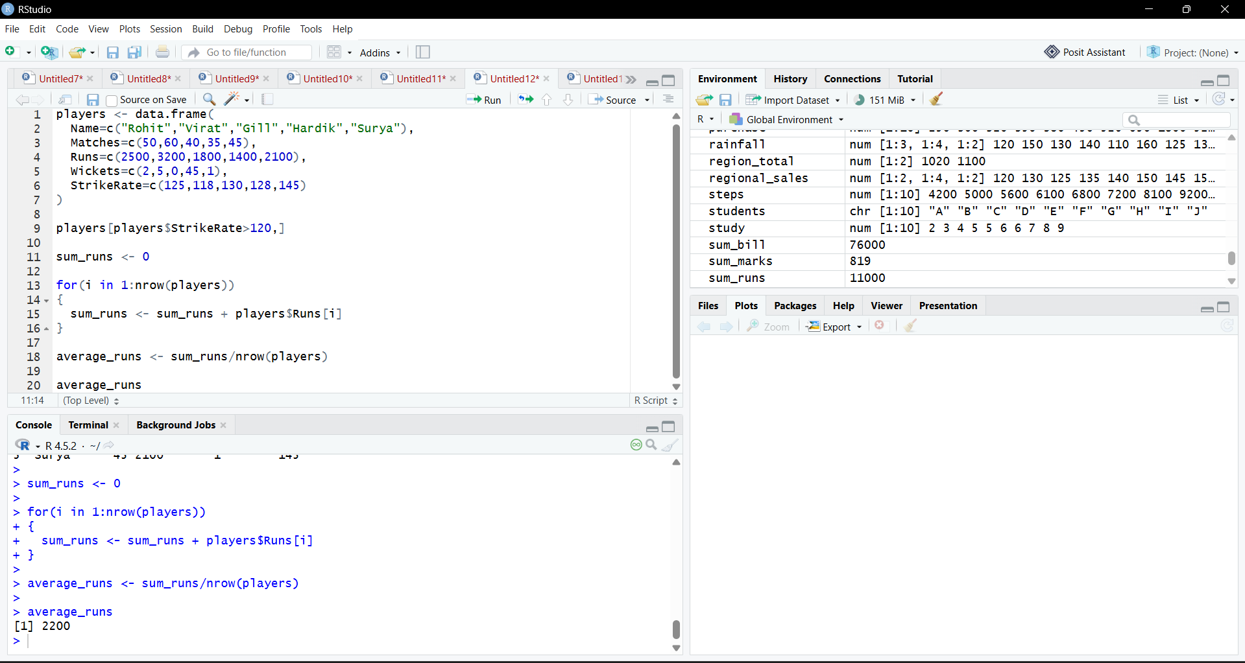
Constraints:
- Identify players with Strike Rate greater than 120.
- Compute the average runs scored.
- Do not use SQL queries or external packages.

Question 7. Bank Transaction Processing (Class Types)
Pseudocode

Start
Create a data frame containing bank details.
Display the class of every column.
Convert account status into factor.
Display the class again.
Verify balance remains numeric.
Stop

CODE:
bank <- data.frame(
AccountNo=c(1001,1002,1003,1004),
Customer=c("Arun","Bala","Cathy","David"),
Balance=c(45000,38000,72000,29000),
Status=c("Active","Inactive","Active","Inactive")
)

sapply(bank,class)

bank$Status <- factor(bank$Status)

sapply(bank,class)

OUTPUT:

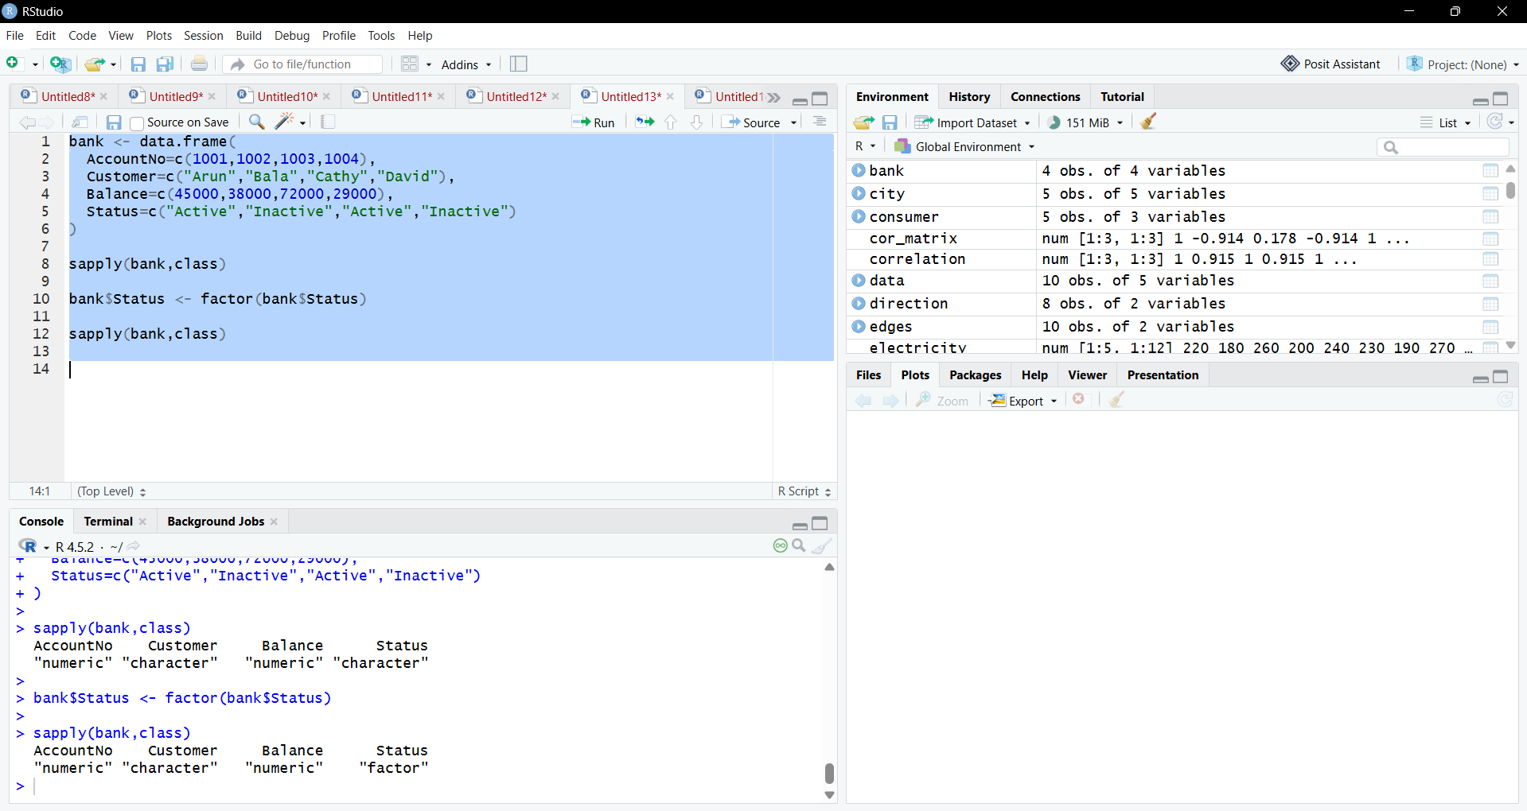
Constraints:
- Students with attendance below 85% are not eligible for examinations.
- Display eligible and ineligible students separately.
- Calculate the percentage of eligible students.

Question 8. University Attendance Management (Vectors and Logical Operations)
Pseudocode
Start
Store attendance percentages in a vector.
Separate eligible students having attendance 85% or above.
Separate ineligible students having attendance below 85%.
Calculate percentage of eligible students.
Display eligible students.
Display ineligible students.
Display eligibility percentage.
Stop

CODE:
attendance <- c(90,82,87,91,79,88,84,95,86,80,92,89,83,97,85)

eligible <- attendance[attendance>=85]

ineligible <- attendance[attendance<85]

eligible

ineligible

percentage <- (length(eligible)/length(attendance))*100

percentage
OUTPUT:
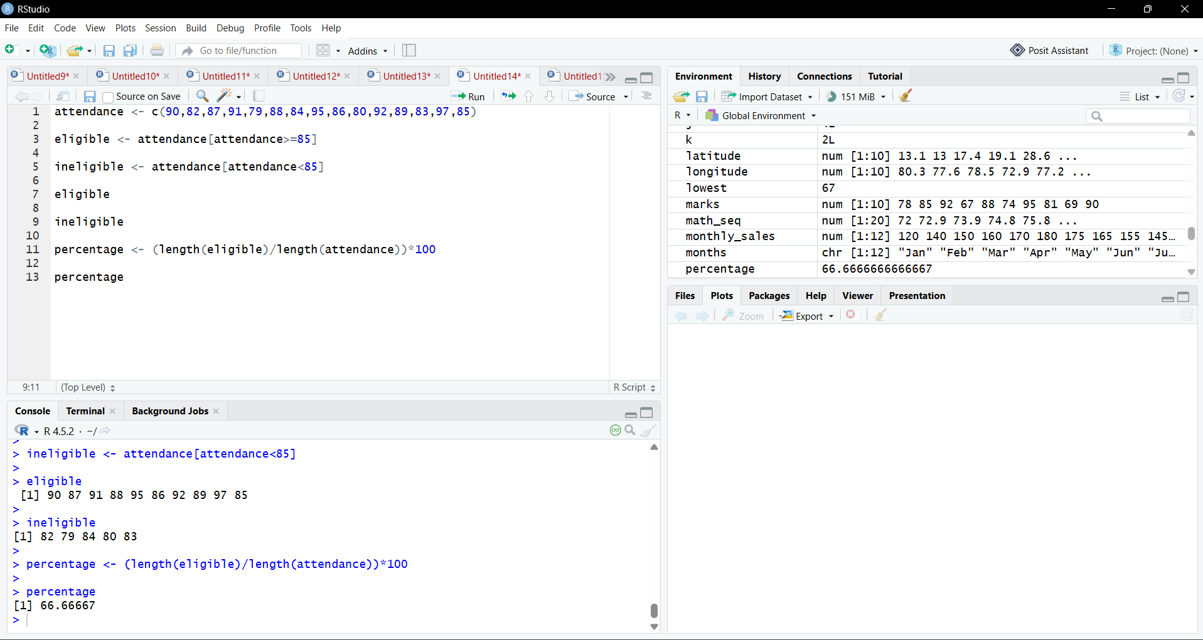
Constraints:
- Students with attendance below 85% are not eligible for examinations.
- Display eligible and ineligible students separately.
- Calculate the percentage of eligible students.

Question 9. Electricity Consumption Analysis (Matrices)
Pseudocode
Start
Create a matrix for monthly electricity consumption.
Calculate annual consumption of each building.
Find the building with the highest annual consumption.
Display annual consumption.
Display building number.
Stop

Code
electricity <- matrix(c(
220,230,210,240,250,260,255,245,235,225,215,205,
180,190,200,210,220,230,225,215,205,195,185,175,
260,270,280,290,300,310,305,295,285,275,265,255,
200,210,220,230,240,250,245,235,225,215,205,195,
240,250,260,270,280,290,285,275,265,255,245,235
),nrow=5,byrow=TRUE)

annual <- electricity %*% rep(1,12)

annual

which.max(annual)

OUTPUT:
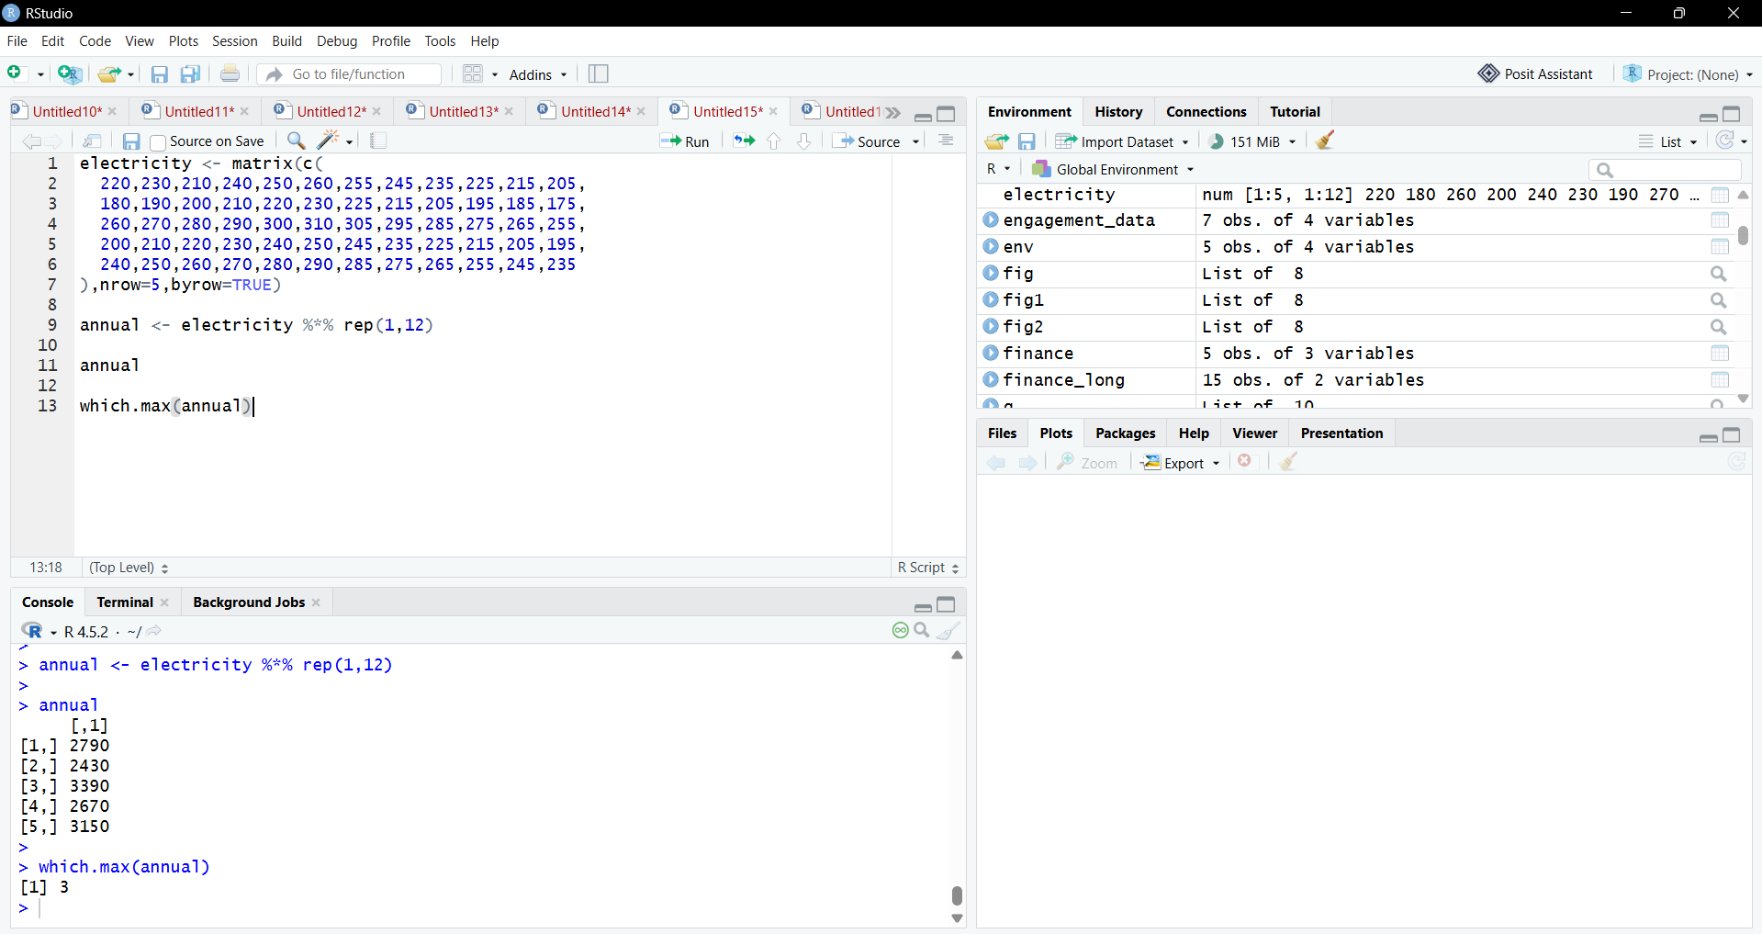
Constraints:
- Calculate annual consumption for each building.
- Identify the building with the highest consumption.
- Use matrix operations only.

Question 10. Sales Performance Dashboard (Vectors, Matrices, Arrays and Class Types)
Pseudocode
Start
Create monthly sales vector.
Create quarterly sales matrix.
Create regional sales array.
Create product categories as factors.
Display the class of each object.
Calculate total annual sales.
Calculate total sales for each region.
Find the best-performing region.
Display annual sales.
Display region totals.
Display best-performing region.
Display quarterly sales.
Stop

Code
monthly_sales <- c(120,140,150,160,170,180,175,165,155,145,135,125)

quarterly_sales <- matrix(c(
410,450,495,405,
430,470,500,420
),nrow=2,byrow=TRUE)

regional_sales <- array(c(
120,130,125,135,
140,150,145,155,

110,120,115,125,
130,140,135,145
),dim=c(2,4,2))

categories <- factor(c(
"Electronics",
"Grocery",
"Stationery",
"Electronics",
"Grocery"
))

class(monthly_sales)

class(quarterly_sales)

class(regional_sales)

class(categories)

annual_sales <- 0

for(i in 1:length(monthly_sales))
{
annual_sales <- annual_sales + monthly_sales[i]
}

annual_sales

region_total <- c(0,0)

for(i in 1:2)
{
total <- 0

for(j in 1:4)
{
for(k in 1:2)
{
total <- total + regional_sales[i,j,k]
}
}

region_total[i] <- total
}

region_total

which.max(region_total)

quarterly_sales

OUPUT:
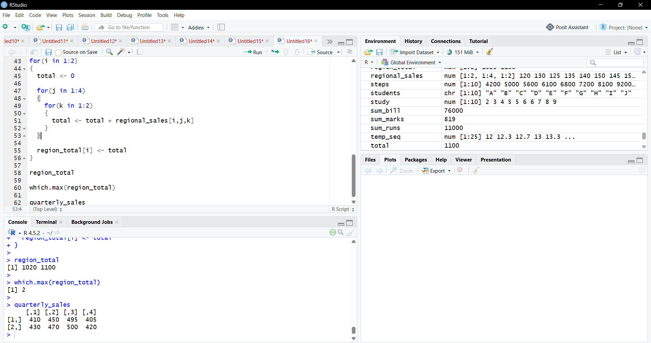
Constraints:
- Compute total annual sales.
- Identify the best-performing region.
- Compare quarterly performance.
- Verify the class type of every object before performing calculations.
- Use only base R functions.

